Notes from: https://www.youtube.com/watch?v=Q3AvZmZEPyc

Creating a basic interactable object in a level:

Parent class should be Actor.

Creates a class, with header:

UCLASS()
class AExampleObject : AActor
{
GENERATED_UCLASS_BODY()

};

and .cpp:

AExampleObject::AExampleObject(const class FPostConstructInitializeProperties& PCIP)
:Super(PCIP)
{

}

adding a sphere component, header:

UProperty( EditDefaultsOnly, VisibleDefaultsOnly )
TSubObject<USphereComponent> TouchSphere;

cpp:

TouchSphere = PCIP.CreateDefaultSubObject<USphereComponent>(this, TEXT("TouchSphereComponent"));
Touchsphere->SetRadius(20.0f,false);
RootComponent = TouchSphere;

adding rotation, header:

UProperty( EditDefaultsOnly, VisibleDefaultsOnly )
float RotationRate;

virtual void Tick(float DeltaTime) OVERRIDE;

cpp:

void AExampleObject::Tick(float DeltaTime)
{
Super::Tick(DeltaTime);

FRotator myRot = GetActorRotation();
myRot.Roll += RotationRate * DeltaTime;
SetActorRotation(myRot);
}

add to constructor in cpp:

PrimaryActorTick.bCanEverTick = true;

creating a blueprint from your c++ class: 15:20 in the video

---------
https://www.youtube.com/channel/UCpsN2TfWGmun4peN2IPgcKg/videos - Reuben Ward

Reuben provides guides on doing various things in Unreal using C++:

https://www.youtube.com/watch?v=3JpNil0_gm4 2019 Ultimate Unreal C++ Guide - Episode 1

Real start of the video: 6:43: details adding components to actors

https://www.youtube.com/watch?v=G-wiuYZGM-8&t=556s - teaches binding input to a pawn

---------

https://wiki.unrealengine.com/index.php?title=Unity3D_Developer%27s_Guide_to_Unreal_Engine_4

---------

Option: https://www.eduonix.com/learn-to-code-by-building-6-games-in-the-unreal-engine?coupon_code=QC15

-------

Creating C++ UIs in Unreal: http://benhumphreys.ca/unreal/ui-cpp-basics/

https://wiki.unrealengine.com/UMG,_Referencing_UMG_Widgets_in_Code

-------
Official Unreal Programming Tutorials

https://docs.unrealengine.com/en-US/Programming/Tutorials/index.html

https://docs.unrealengine.com/en-US/Programming/Tutorials/Components/index.html

Unreal Forum Post on helping learn programming:
https://forums.unrealengine.com/development-discussion/c-gameplay-programming/8694-getting-started-c-gameplay-programming-references

At 2:34, Discusses printing debug logs to the screen using the universal GEngine pointer
https://unrealcpp.com/character-bind-button/

if(GEngine)
{
GEngine->AddOnScreenDebugMessage(-1,5.f,FColor::Green,TEXT("Pushing button") );
}

Using the output log window and printing to log files for debugging
https://wiki.unrealengine.com/Logs,_Printing_Messages_To_Yourself_During_Runtime

Unreal Interface Classes:
https://isaratech.com/ue4-declaring-and-using-interfaces-in-c/
https://wiki.unrealengine.com/Interfaces_in_C%2B%2B
https://www.youtube.com/watch?v=B1Knl19boJ0
https://www.udemy.com/course/building-an-unreal-rts-game-the-basics/learn/lecture/6997724#overview around 6:00

----UI Programming
Building User Interfaces with UMG and C++:
https://blog.gamedev.tv/creating-unreal-engine-ui-with-umg-and-c/
https://unrealcpp.com/health-bar-ui-hud/
https://wiki.unrealengine.com/UMG,_How_to_extend_a_UUserWidget::_for_UMG_in_C%2B%2B.
https://wiki.unrealengine.com/Extend_UserWidget_for_UMG_Widgets
-------

Setting a collision response to a collision channel:
https://docs.unrealengine.com/en-US/API/Runtime/Engine/Components/UPrimitiveComponent/SetCollisionResponseToChannel/index.html
https://docs.unrealengine.com/en-US/API/Runtime/Engine/Engine/ECollisionChannel/index.html
https://docs.unrealengine.com/en-US/API/Runtime/Engine/Engine/ECollisionResponse/index.html

code:

GetCapsuleComponent()->SetCollisionResponseToChannel(ECollisionChannel::ECC_Visibility, ECollisionResponse::ECR_Block);
-------

Creating reactive grass: https://www.youtube.com/watch?v=1bD_6YFkyZo

Creating footprints: https://www.youtube.com/watch?v=JI84nFuLMSo

-------
Compile Options for faster compile on small changes(from '14, might no longer be valid):

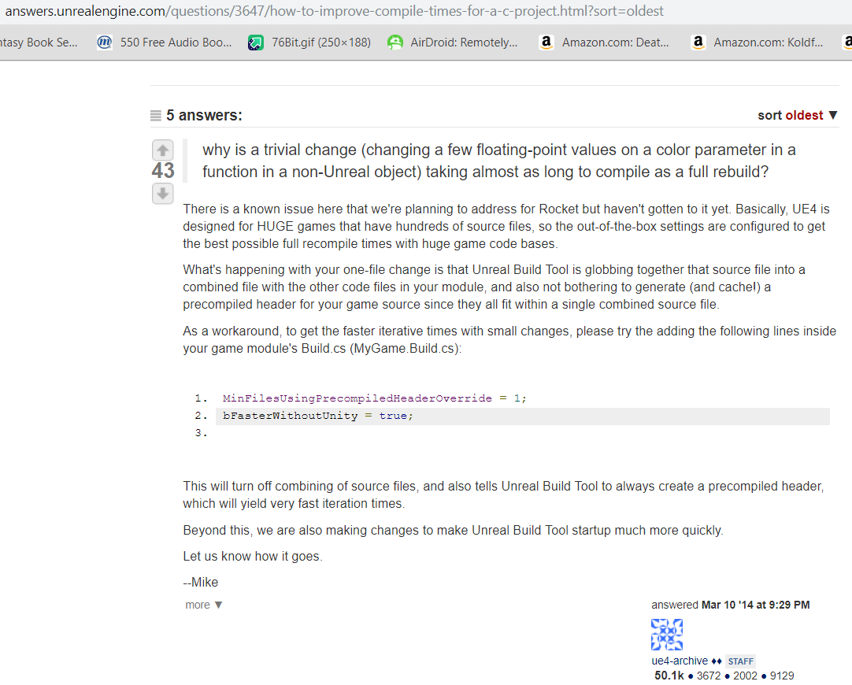

---------

Installing and setting up the Unreal Extension for Visual Studio
https://docs.unrealengine.com/en-US/Programming/Development/VisualStudioSetup/UnrealVS/index.html

